  - Instruction:
Complete all questions in 1 hour.
- The table below shows the Truth table of Half Subtractor, write SOP expression for difference and borrow and design the circuit using Logsim.

A | B | Difference | Borrow
0 | 0 | 0 | 0
0 | 1 | 1 | 1
1 | 0 | 1 | 0
1 | 1 | 0 | 0

SOP expressions
Difference: A’B + A.B’
: A ⊕ B

Borrow : A’.B

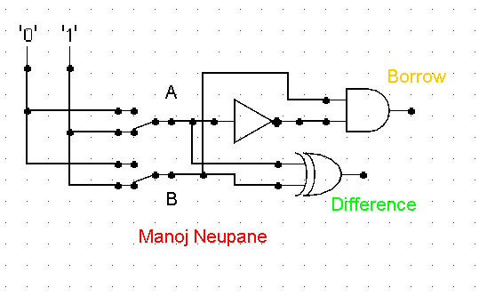

- Design 2:4 decoder using logsim and Construct Truth table.
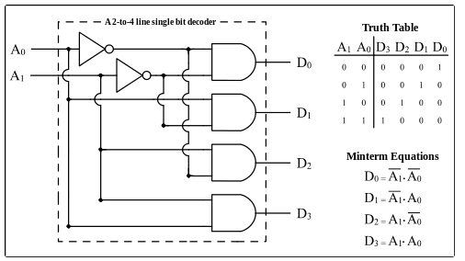

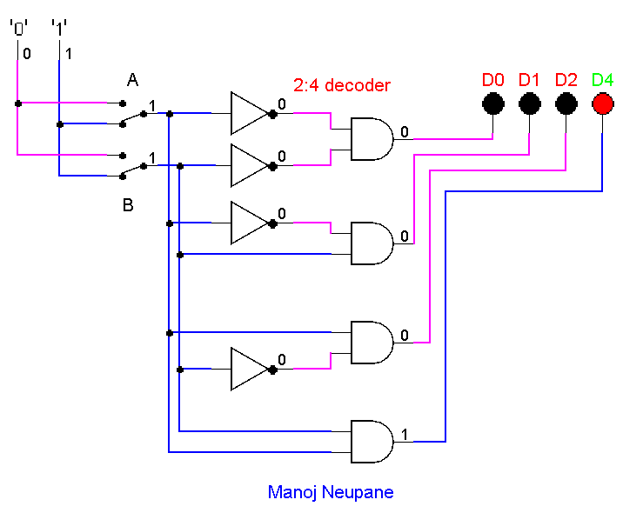

A | B | D0(A’.B’) | D1(A’.B) | D2(A.B’) | D3(A.B)
1 | 1 | 0 | 0 | 0 | 1
1 | 0 | 0 | 0 | 1 | 0
0 | 1 | 0 | 1 | 0 | 0
0 | 0 | 1 | 0 | 0 | 0

- Draw the following simple ALU circuit using LogSim and describe the outputs when instructions are 1 and 0.
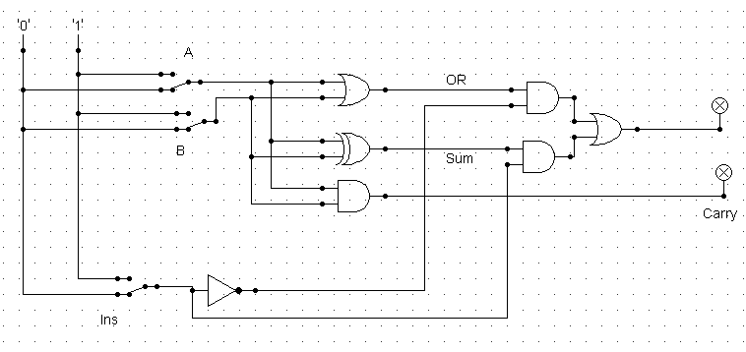
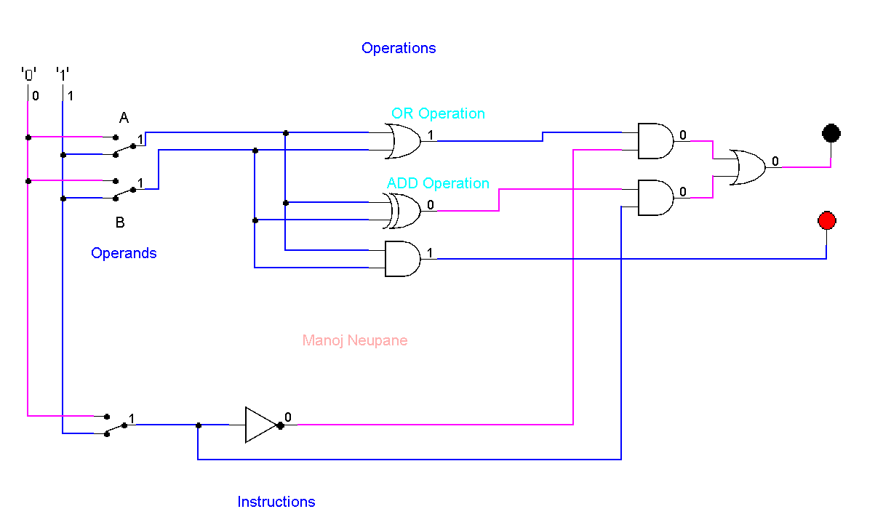

- Write sort notes on the following topic:
- ALU
Answer:

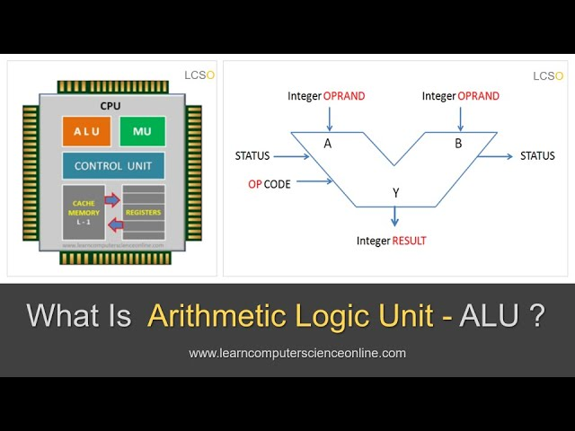
Figure 1 ALU (Arithmetic Logic Unit) (learncomputerscience, n.d.)
ALU (Arithmetic Logic Unit) is the part of the CPU where all the arithmetic calculations happen. It is a collection of many logical functions. The basic arithmetic functions in ALU are Addition, Multiplication, OR, AND, etc.
The ALU can be divided into 2 parts i.e., AU (Arithmetic Unit) and LU (Logic Unit). AU performs all the arithmetic calculations like addition, subtraction, multiplication, etc and LU performs the logical calculations like AND, OR, XOR, NOT, etc. The ALU is connected directly to the RAM (Random Access Memory) or main memory and input devices. The data from input devices and towards output devices from the CPU’s registers flow in bus. The instructions from the input devices are firstly loaded to the ALU’s registers by CU and then the instruction part is sent to the decoder and the operands are passed to the AU or LU by the CU. After the functional units are performed, the results from the units move forward to the Multiplexor to their corresponding AND logic. Simultaneously, the decoder’s output (the instruction) is connected to the corresponding AND as second input. If the decoder’s output is high, then only its output is passed through the multiplexor. All other results are blocked by the low output of decoder. In this way, the correct output of ALU is selected.

- Decoder
Answer:
Decoder is the part of CU which selects the output from the ALU as per the
instruction. For example, if Addition instruction is passed to the decoder, it will
let the result of only addition to pass through the multiplexor. It is a
combinational circuit which produces 2^{n} output lines where n is the input
lines. Only one of the output lines is high according to the input lines(instruction)
which is then passed as control to the multiplexor to select the desired output from
the ALU.

- Multiplexer
Answer:
Multiplexor is the combinational circuit which has many input data and a single
output data. It takes many inputs from the ALU and selects the output as per the
output instruction from the decoder. All the input data are passed through the
corresponding AND gates and the corresponding decoder’s instruction as second
input to the AND gate. This. will only let the output who’s corresponding
instruction from decoder is high to pass through.

